## **Schoolinks: Student Requesting Letters of Recommendation**

## 

## **1. Accessing the College Application to request a Letter of Recommendation**

Start by clicking the **Colleges** icon, then **College Applications**.

## **2. Select the College Application**

***Note***: If you haven't started tracking any college applications in SchooLinks yet, you should grab a handout on the “How To” table with those instructions.

Here, you will select the application for which you need to request a letter of recommendation by clicking on the School or the **Edit** pencil.

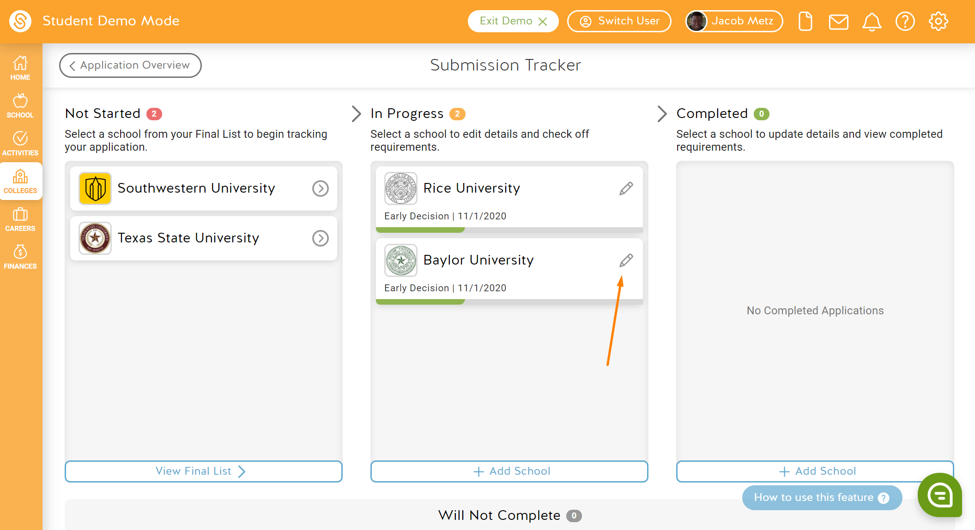

## **3. Adding a Letter of Recommendation**

On the college's application requirement page, if the school requires a specific number of recommendations you will click on **Add Recommender**. If requirements are optional you will click on **Request Teacher Recommendation.**

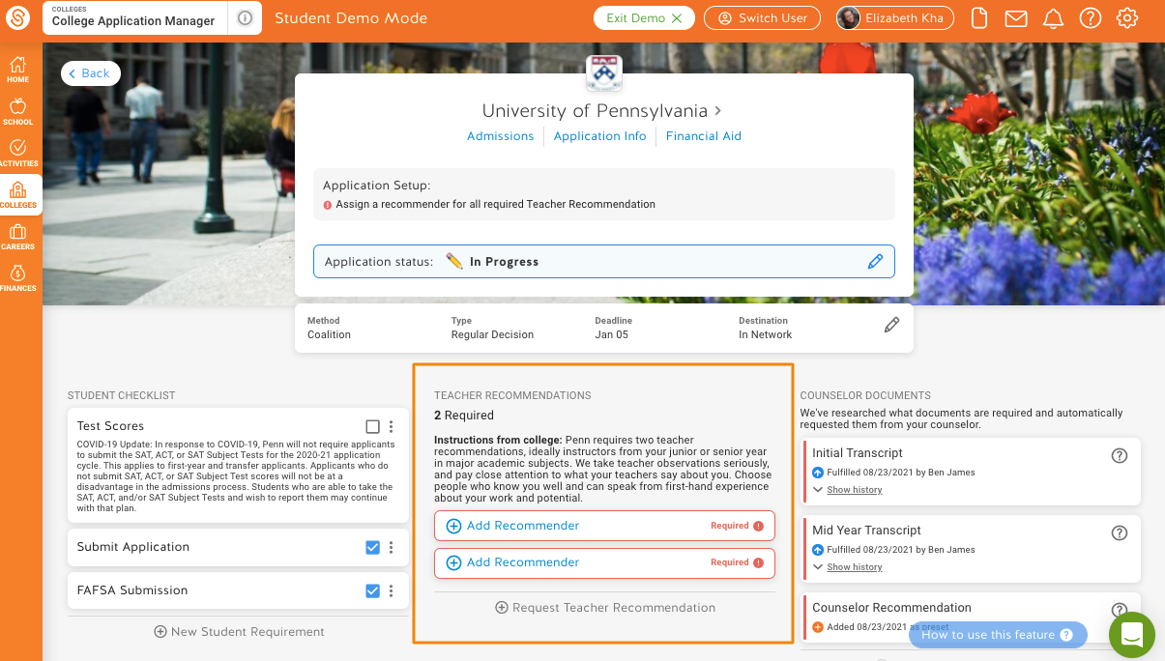

## 

## **4. Selecting your Recommender**

**Adding a Recommender**

You have a few options when it comes to determining who you would like to request an evaluation from:

1. Choose an existing recommender
2. Request a recommendation from a new teacher with an account
3. Request a recommendation from a new teacher without an account

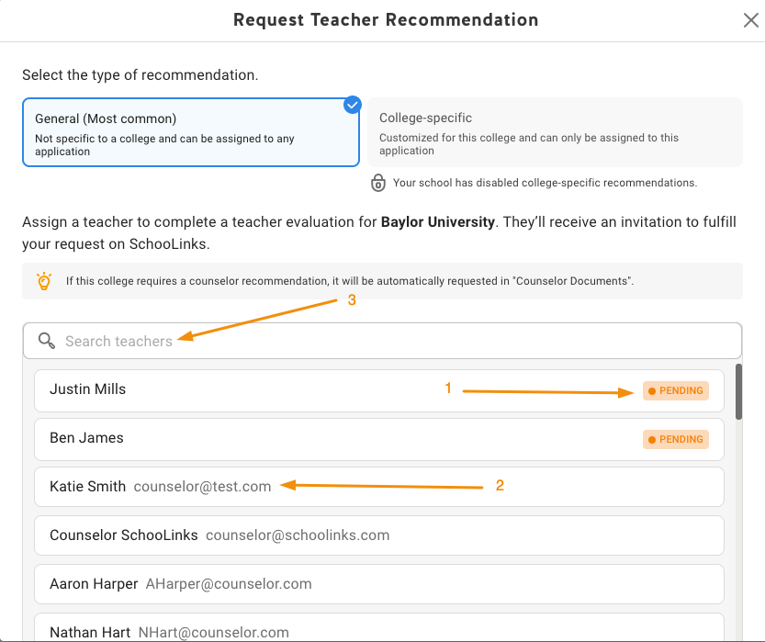

**Choose an existing recommender to assign to this application**

If you have already requested a teacher evaluation for another school, you can assign an existing teacher to this school. These teachers will show up as Pending, Declined, or Fulfilled depending on the status of the already submitted recommendation.

### **Request a recommendation from a new teacher who has a SchooLinks account**

You can also request a recommendation from a new teacher by searching for them by name in the search field.

### **Request a recommendation from a new teacher who does NOT have a SchooLinks account by adding them manually**

If after searching for your teacher you don’t see the teacher listed, you can click **Add them Manually**. This will open up an option for you to provide their First and Last Name and Email to request a recommendation from them. Note: You must use the search first in order to see this option.

After you've selected or added your recommender, click **Submit Request**. We'll send them an email with a link to add a letter of recommendation for you, and you can see when they've submitted their recommendation.

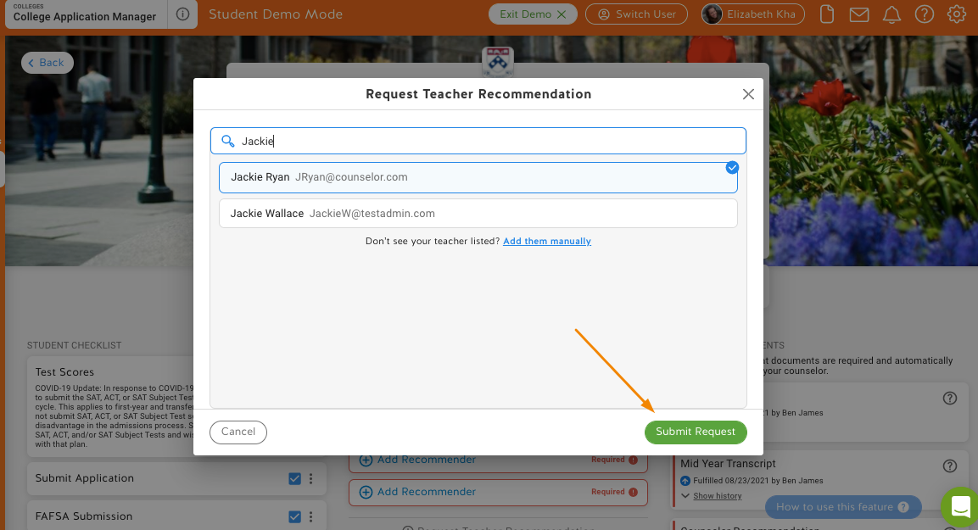

## 

## **5. Tracking and Editing your Letters of Recommendation**

Requesting a recommendation is only the beginning of the process - the next step is ensuring that the teacher completes the request. If you'd like to check on the status of all of your requests for a Letter of Recommendation (non-Common App) or Teacher Evaluations (Common App) or want to change your recommender to someone else, you can do so in [Tracking and Editing Teacher Evaluations and Letters of Recommendation.](http://support.schoolinks.com/en/articles/4513212-tracking-and-editing-teacher-evaluations-and-letters-of-recommendation-as-a-student)